|  |
| --- |
|  |
| KCERT 2050 |
| Operational Manual, 20/07/2022 |

# Introduction

Kenya Carbon Emission Reduction Tool (KCERT) is an open-source climate and energy system model. KCERT was adapted to the local context following the general model structure of the Mackay Carbon Calculator developed by the Department for Business, Energy, and Industrial Strategy (BEIS) to calculate UK carbon emissions and future carbon pathways. KCERT follows the Calculator approach supported by BEIS international outreach work (Davis et al., 2018). The Calculator approach emphasises that net-zero is a whole system problem placing demand and supply-side actions as core features. The timing of actions is also central and considers issues around how quickly technology can be deployed or how fast the population can adjust behaviour towards the 2050 target year. KCERT aims to aid individuals, at a high level for the non-expert, and intricate detail for the expert, in understanding the options for meeting Kenya’s emissions targets, identify any crucial decision points and engage the public in the debate by helping them to understand the trade-offs. KCERT will be hosted at the Ministry of Energy for use by government officials, policymakers, and stakeholders. Interested partite will be able to interact with the web tool through the portal on the Ministry of Energy portal and download the detailed excel tool.

KCERT calculates Kenya’s carbon emissions and allows for identifying and exploring the range of scenarios for cutting greenhouse gas emissions, including net-zero by 2050. The scenarios are based on accounting for how energy is produced, converted, and consumed showing the extent to which energy technology, behaviour and land-use change might impact the country’s greenhouse gas emissions. Fundamental changes were made to the original Mackay Carbon Calculator to accommodate the local context. These include:

* Kenyan-specific data on energy demand and supply, and social and economic indicators based on extensive literature review and expert consultation.
* Sectoral coverage reflects Kenya’s energy demand and supply. For example, buildings heat demand only focuses on hot water as space heat is not a priority in the local context; the industry sector saw the removal of refineries and chemical industries and the inclusion of tea and sugar.
* The technology options provided are based on Kenya’s situation. For example, the model assumes a decentralised supply of gas in contrast to the centralised gas grid approach followed in the Mackay Carbon Calculator.

KCERT is an excel-based tool that calculates Kenya’s greenhouse gas emissions and future carbon pathways. Users have the option to develop their energy and land-use pathways to the year 2100 with decision levers. The decision levers represent both demand and supply side decarbonisation actions co-developed with sectoral experts, civil society actors and public administrators through extensive stakeholder engagement facilitated by co-design workshops, which aimed to define the possible levers for reducing greenhouse gases and parametrise these decision levers by associating ambition levels to each of these levers. In total, about 41 levers with a total of 162 sub-levers defined with 4 different ambition levels for each lever. The outputs of these pathways are visualised in form of interactive graphs focused on greenhouse gas emissions, energy use, technology demand and land use for different areas of the energy system. The tool covers five energy demand and supply sectors of the economy namely electricity generation, transport, industry, land use, and residential and commercial buildings.

KCERT serves several purposes: as a comprehensive data repository for demand and supply of energy for the key sectors of the economy; as a forecasting tool for energy demand and supply and greenhouse gas emissions to 2100; as a policy analysis tool, it analyses and visualises the impact of potential decarbonisation actions on energy demand and supply and greenhouse gas emissions. The current version of the KCERT tool does not visualise the cost implications of technology adoption or reduction. This is because of the current uncertainties around cost more so for new technologies such as hydrogen cars and carbon capture and storage. However, provisions for cost modelling have been built into the model for future consideration. Additionally, the tool focuses on greenhouse gas emissions, air quality vectors are captured in the tool for consideration in future versions.

# Getting Started

KCERT is an analytical excel spreadsheet model that models the Kenyan energy system, calculates Kenya’s greenhouse gas emissions, and allows you to explore pathways to decarbonisation, including net-zero by 2050 and on to 2100. The spreadsheet model is accompanied by an interactive online tool that allows individuals to select options for meeting emissions targets and view the impact of these options on the key metrics for the different areas of the energy system. KCERT takes a sector-by-sector scenario approach and links energy supply and energy demand sectors within a framework for creating the pathways for reducing emissions as discussed in the following sections.

## Sectoral Coverage

KCERT takes a sector-by-sector approach by covering sectoral energy supply and demand of the Kenyan economy. The sectors covered are summarised as follows:

|  |  |
| --- | --- |
| Energy Supply Sectors | Energy Demand Sectors |
| Electricity Generation   * Renewables: Solar PV, Geothermal, Wind Onshore, Hydropower * Thermal Powered Plants * Nuclear power * Interconnectors | **Transport**   * Passenger transport * Freight transport |
| Biomass energy supply   * The volume of waste and recycling * Bioenergy production | **Residential and Commercial Buildings**   * Hot water supply * Cooking * Lighting, and appliances * Cooling |
| Hydrogen production   * Hydrogen production for industry | **Industry**   * Industrial activity * Carbon Capture and Storage (CCS) |
|  | **Farming and Forestry**   * Agricultural processes * Bioenergy resource availability |

## Levers of ambition

The pathways for reducing emissions are based on a set of parameters or variables called “levers,” which constitute the backbone of KCERT. The levers represent different effort levels or trajectories towards sectoral decarbonisation. Each lever is assigned an ambition level or maximum effort needed for transitioning to a low-carbon society. KCERT has four levers that go in the direction of minimal effort (level 1) to progressively higher ambitions to the maximum effort deemed plausible (level 4) for decarbonisation as illustrated in Figure 1.

Figure 1 Levers of Ambition setting in KCERT

The levers and associated ambition levels were set in consultation with experts across industry and academia. These actors participated actively in one or several sectoral workshops where they defined the possible levers for the reduction of greenhouse gases and parametrised those levers, which is associated different ambition levels to each of the levers. The levers represent both technological shifts and behavioural or lifestyle changes.

## Co-design Workshops

The levers were developed through participative construction of low carbon scenarios. A pool of experts and actors from the civil society, universities and public administrations at different levels were identified with the purpose of covering the wider spectrum of various knowledge and views on the transition.

These actors participated actively to one or more of the numerous sectoral workshops. The purpose of each of these workshops was to define, among a limited but representative set of participants, the possible levers for the decarbonisation of each sector, as well as to parametrize those levers, i.e., to associate different ambition levels to each of these levers.

These levers constitute the backbone of KCERT. Some of them are of a technological nature, for example the penetration of electric vehicles or the renewable energy for electricity production. Others relate to behavioural, lifestyle changes such as changes in air conditioning demand or in diets for example a shift in reducing consumption of red meat form cattle to white meat. The sector leads helped define low carbon scenarios by making choices on the level of ambition for each of the levers. The purpose of this step was to co-construct different technical storylines, contrasting alternative pathways towards a reduction of Kenya’s GHG emissions.

## Calculation Procedure

For each sector, KCERT follows a general five-step calculation procedure:

1. The user-controlled lever and ambition levels for the decarbonisation scenarios are set for each sector.
2. Deployment trajectories for supply or demand scenarios are calculated using a logical statement that applies and or interpolates the user selected ambition levels based on the lever start and end years.
3. Sectoral activity and outputs are calculated based on the deployment trajectories.
4. Energy balance trajectories that represent energy consumption are calculated based on the activity level and energy intensity of the technology.
5. Emissions are calculated by applying the emission factors for the input resource or output fuel to the respective energy balance.

## Base Year

All scenarios start from a common base year. KCERT 2050 adopts 2015 as a base-year across all sectors, homogenously, with agreement between all sector leads. The 2015 base year was selected for consistency reasons and due to limitations on data availability, data convergence, and model parsimony.

# KCERT Excel Model

KCERT excel-based model provides a detailed structure of the model as well as underlying data and assumptions. The Excel Spreadsheet model provides the fundamental model, data, and calculations on which the Web Tool was developed.

## Buildings Heat Module

This module defines the heat demand and method of supply for domestic and non-domestic hot water. In contrast to the Mackay Carbon Calculator, domestic and non-domestic space heat is out of scope in the Kenyan context.

### Key Interactions

The module influences the electricity module due to fuel demands for heating hot water.

### Buildings Hot Water Demand Lever

The building's hot water demand lever allows a user to control the ambition levels for hot water demand per person for domestic buildings (domestic hot water demand is calculated per person and is assumed to scale with the number of people in Kenya not the number of dwellings) and per unit floor area for non-domestic buildings relative to the base year as an index. The index measures the gradual growth in demand through additional hot water use given the growth in population or amount of non-domestic buildings per unit floor area.

Domestic and non-domestic demand for hot water is calculated gradually by modifying a baseline trajectory to achieve the stated ambition level selected by the user. First KCERT calculates the base year demand per unit (DemUnitBY) by dividing the heat supplied for hot water by the base year population or floor area for domestic and non-domestic buildings, respectively. The base year demand per unit is then used to calculate the business-as-usual hot water demand per unit trajectory (DemUnitBAU) by multiplying the DemUnitBY by the business-as-usual index. Next the calculator obtains the hot water demand unit in the target year (i.e., when the level of ambition is realised) (DemUnitTY) by multiplying the DemUnitBY by the lever selected ambition level demand per unit index. The demand per unit index trajectory used to gradually modify the business-as-usual hot water demand per unit trajectory to achieve stated ambition level is calculated as:

1. If the current year is less than the start year apply 1,
2. If the current year is greater or equal to the start year + time to deploy (target year) apply the DemUnitTY divided DemUnitBAU
3. Else apply a linear interpolation between 1 in the start year and the target year index in the target year.

Lastly, hot water demand per unit (DemUnit) is calculated by multiplying the business-as-usual demand profile (DemUnitBAU) by the demand per unit index.

The overall domestic demand for hot water (Dem.dDwl.dHW) is calculated by multiplying the demand per unit for domestic buildings and the population. Figure 2 shows the projected demand for domestic hot water as heat supplied in TWh for each of the four levers. At the ambition end we expect a reduction of about 1.2 TWh of heat supplied for hot water if we adopt ambitions Lever 4 strategies to reduce population demand for hot water.

Figure Projected domestic hot water demand over time by lever selection in TWh

Similarly, overall non-domestic demand for hot water (Dem.nFlrl.dHW) is calculated by multiplying the demand per unit for non-domestic buildings by the amount of floor area . Figure 3 summarises the hot water demand as heat supplied TWh to non-domestic buildings. Non-domestic building compared to domestic has a slower increase over time due to the difference in growth of population versus that of non-domestic building floor area. This is also reflective of the Kenyan context given the rise in demand of residential buildings expected to continue with the growing population.

Figure Projected non-domestic hot water over time by lever selection in TWh

### Buildings Hot Water Deployment Lever

The domestic and non-domestic deployment levers control the ambition levels for the share of energy technologies used to meet the demand for hot water in domestic and non-domestic buildings. Kenya’s domestic and non-domestic hot water energy supply lever saw significant modifications to fit the local context. The modifications to the fuel sources for hot water heating for domestic and non-domestic water heating were as follows:

|  |  |  |  |
| --- | --- | --- | --- |
|  | Retained KCERT | Added KCERT | Removed (Mackay) |
| Domestic | Electricity | Solar, Wood | Oil fuel, solid fuel, gas boiler, biomass |
| Non-Domestic | Electricity,  Fossil fuel (oil) boiler | Solar, Wood | solid fuel boiler, gas boiler, biomass |
|  |  |  |  |

KCERT assumes hot water heat demand supplied by other fuels for example kerosene, charcoal and gas have a small share in the overall mix and thus KCERT considers these fuels for meeting cooking heat demand.

KCERT apportioned the energy used per fuel for both domestic and non-domestic were apportioned based on overall energy used in hot water heating as follows:

|  |  |  |
| --- | --- | --- |
|  | Domestic | Non-Domestic |
| Electricity | 69.80% | 20% |
| Solar | 0.54% | 0.54% |
| Wood | 29.66% | 5% |
| FF Boiler | - | 74.66% |
| Total energy Hot Water | 258 kToe | 19.1436 KToe |
|  |  |  |

For both domestic and non-domestic buildings, the user controls the share of heat demand met by the selected technologies based on the ambition levels set by experts via the stakeholder engagements. The shares of the technologies are determined by applying the following logical statement:

1. If the current period is before the start year KCERT applies the base year share/penetration.
2. If the current period is after the chosen ambition level has been achieved (more than the speed of deployment since the start year) the selected share/penetration is applied.
3. Else if the current period is between the start year and the calculated completion year the share/penetration is linearly interpolated between the base year level (in start year) and the selected level (in completion year).

Hot water supplied by each technology is calculated by multiplying the overall domestic demand (Dem.dDwl.dHW) and non-domestic demand (Dem.nFlr.dHW) for hot water by the technology demand share.

Figure 4 summarises the heat supplied for hot water by heating technology in domestic buildings. Unlike the Mackay Carbon Calculator, the deployment priority is based on the ambition levels set for the share penetration of electricity, solar and wood. The decarbonisation strategy focuses on reducing the use of wood and increasing the use of solar water heating relative to electricity use in domestic buildings.

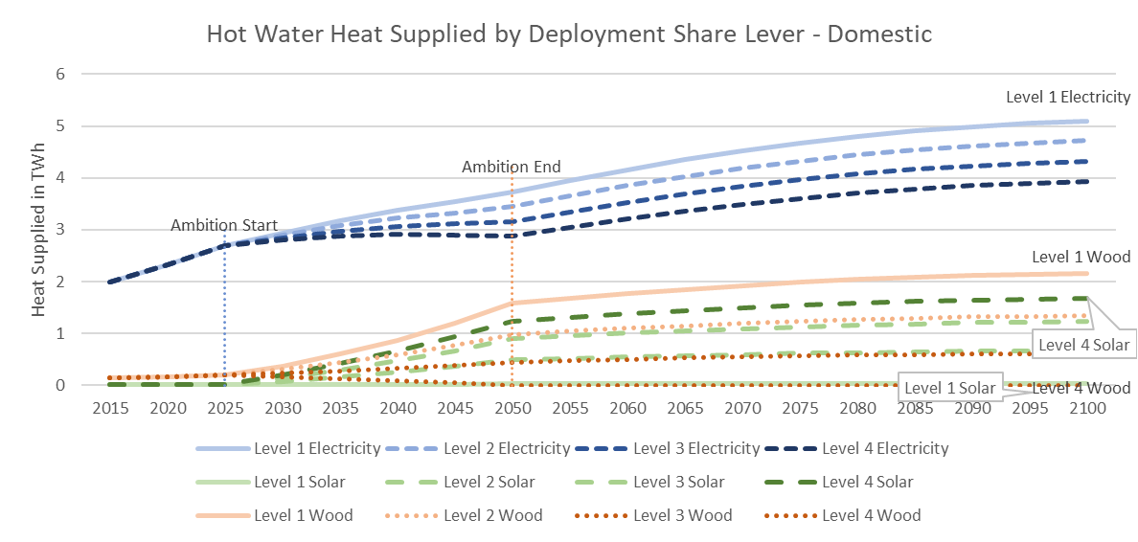

Figure Heat supplied for hot water heating in domestic buildings by deployment technology

Similarly, the deployment priority of hot water heating technology for non-domestic buildings is based on the ambition levels set for the share penetration of fossil fuel boilers in addition to electricity, solar and wood heaters. The decarbonisation strategy focuses on reducing the use of fossil fuel boilers and wood heaters while increasing the use of solar water heating relative to electricity use in domestic buildings.

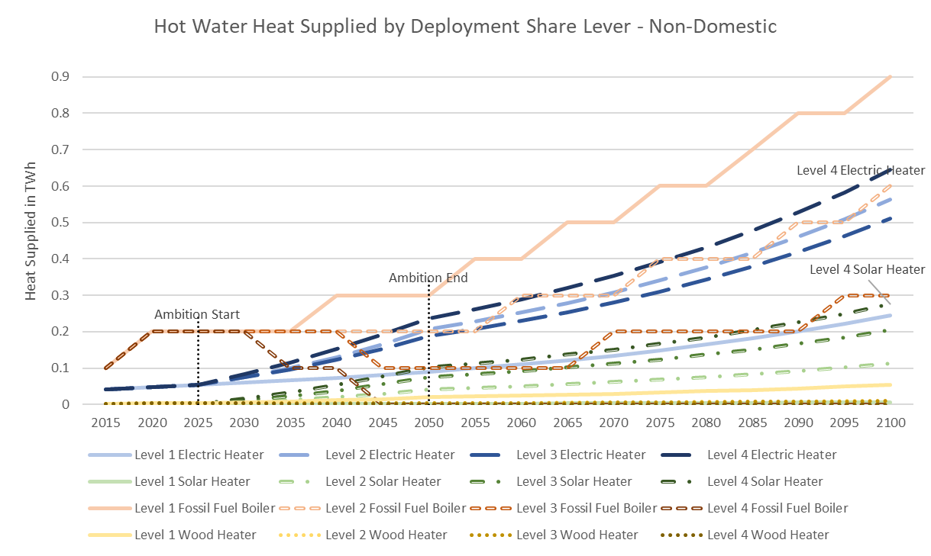

### Buildings Hot Water Technology Emissions

The greenhouse gas emission outputs for each water heating technology are calculated by multiplying the fuel input by the associated emission factor. The fuel input calculated by dividing the activity per heating technology by their respective heat efficiency.

Conversion losses calculated as the difference between the energy content of fuel inputs and useful outputs. The net energy balance for each technology calculated as the sum of the energy vectors in the energy balance as a checksum (should equal zero so that energy is not created or destroyed).

Greenhouse gas emissions from hot water use in domestic buildings are attributable to the use of wood as the heating technology. Figure 5 shows the greenhouse gas emissions given by lever of ambition. Reduction of general demand unit index for hot water and use of electricity and solar heaters achieves net-zero by 2050 for domestic buildings hot water demand.

Figure Greenhouse gas emissions domestic wood heater

On the other hand, greenhouse gas emissions from hot water use in non-domestic buildings are attributable to the use of fossil fuel boilers and wood as the heating technology. Graph Figure 6 shows minimal amounts of greenhouse gas emissions from wood heaters given their minimal use. Fossil fuel boilers on the other hand contribute to a steady increase in greenhouse gas emissions over time under business as usual. Interventions that shift heat supply to electricity and solar heaters are needed to bring the emissions from non-domestic hot water heating to net-zero.

Figure Greenhouse gas emissions non-domestic water heating

## Buildings Non-Heat Module

This module covers energy and emissions from all non-heat demands in domestic and non-domestic buildings. More specifically, the module defines the energy consumption required to satisfy the demand for cooking, lighting and appliances and the resulting emissions.

KCERT includes a domestic dwelling cooking lever to account for the diverse sources of fuel inputs from those used in heating hot water. This lever covers cooking demand for domestic buildings and institutions. Decarbonisation of domestic cooking is based on the selection of cleaner inputs that is lever controlled. Thus, the user controls the share penetration of the selected cooking energy processes.

The lighting, appliances, and cooling modules are consistent with the Mackay carbon calculator. The KCERT assumed the modes of lighting and use of appliances and air conditioning do not differ between the Mackay Carbon calculator and the Kenyan context. Decarbonization scenarios are based on reducing demand for lighting and appliances per unit and efficiency improvements in lighting and appliances in domestic and non-domestic buildings. Therefore, the user controls the energy service demand per unit and the energy intensity of delivering demand.

### Key Interactions

The module influences the electricity module due to fuel demands for cooking, cooling, lighting, and appliances.

### Domestic Dwelling Cooking Lever

The domestic dwelling cooking lever controls the energy demands needed for cooking in domestic buildings and institutions. The user has no direct control over non-domestic cooking as non-domestic cooking efficiency via primarily gas and electricity were deemed not to have significant room for improvement. The domestic dwelling cooking lever controls the share of energy supply used to meet the demand for cooking in domestic buildings and institutions.

The demand for domestic and institutional cooking follows the same assumption as the heat supply for hot water module, whereby demand is calculated per person proportional to population. Demand per unit domestic and institutional cooking is calculated as the energy used for cooking per person in the base year times the efficiency weighted by the base year share of the following cooking processes:

|  |  |  |
| --- | --- | --- |
|  | Retained KCERT | Added KCERT |
| Domestic | Electric Stove  Gas (LPG) stove | Biomethane stove  Bioethanol stove  Biogas stove  Kerosene stove  Charcoal stove  Woodstove |
| Non-Domestic | Electric Stove  Gas (LPG) stove |  |
|  |  |  |

Total domestic and institutional cooking demand is calculated by multiplying the demand per person by the population.

Users control the share of domestic and institutional cooking by the selected processes. The shares of the technologies are determined by applying the following logical statement:

1. *If the current period is before the start year KCERT applies the base year share/penetration.*
2. *If the current period is after the chosen ambition level has been achieved (more than the speed of deployment since the start year) the selected share/penetration is applied.*
3. *Else if the current period is between the start year and the calculated completion year the share/penetration is linearly interpolated between the base year level (in start year) and the selected level (in completion year).*

Domestic cooking energy demand supplied each cooking technology is calculated as the total domestic and institutional cooking demand multiplied by the gas technology share. Figure 7 shows the business-as-usual cooking energy demand projected to the year 2100. At business as usual, domestic used of wood for cooking is slated to increase to 45% in 2050 from 30% in 2015.

Figure Domestic cooking energy demand by cooking process - BAU

The priority order for cooking technologies is based on the ambition levels. At level four we see prioritisation of electricity for cooking from the year 2050 assuming we achieve 100% electrification of urban areas by 2022 and rural areas (including through off-grid technologies) by 2030.

Figure Domestic cooking energy demand by cooking process at Lever 4 ambition levels

### Domestic and Institutional Cooking Emissions

Energy balance is calculated based on the energy supplied (activity) and efficiency for each input fuel. Greenhouse gas emission outputs for each cooking technology is calculated by summing fuel input multiplied by the emission factor, for each fuel consumed. Emissions from cooking energy demand arose primarily from domestic cooking due to the use of dirty fuels such as kerosene. Decarbonisation strategies could look into cleaner cooking technology such as biomass cookstoves, briquettes and at the most ambitious level, electric cookstoves.

Figure Emissions from domestic cooking energy demand by cooking technology

### Lighting, Appliances and Cooling Demand Lever

Domestic and non-domestic demand for lighting and appliances lever follows the same assumption as the hot water demand levers. Demand is calculated per person and per unit floor area for domestic and non-domestic buildings, respectively. Demand is assumed to grow proportional to the population while non-domestic demand is assumed to grow in line with the floor area. The levers allow users to control the index of the energy demand per person or per unit relative to the base year.

Domestic and non-domestic demand for cooling is defined as the share of dwellings with air conditioning and the index of demand per unit floor area, respectively. Domestic and non-domestic cooling demands are defined in terms of the electricity required to deliver the service. For domestic energy service demand, the user controls the share of dwellings assumed to have air conditioning installed. While for non-domestic energy service demand, the user controls an index for cooling demand per unit floor area relative to the base year.

The demand per unit index is calculated by multiplying the business-as-usual index by an adjustment factor to gradually transition between the business-as-usual profile and the target ambition level. This factor is defined by the function:

1. If the current year is less than the start year apply 1,
2. If the current year is greater or equal to the start year + time to deploy (target year) apply the target demand divided by business-as-usual demand,
3. Else apply a linear interpolation between 1 in the start year and the target year index in the target year.

Lighting and appliances, and cooling demand are described in terms of the energy required to meet it due to difficulties in quantifying the actual service demand in a measurable way. The demand per unit is calculated by multiplying the base year demand per unit by the service demand index (behaviour) and the energy intensity index (user-controlled efficiency improvements). The total demand is calculated as demand per unit by the appropriate unit that is population or floor area.

### Lighting, Appliances and Cooling Efficiency Lever

The efficiency lever allows the user to control the ambition levels for the energy intensity of delivering demand in lighting, appliances, and cooling. Decarbonisation strategy focuses on efficiency improvements that reduces the energy used by lighting, appliances, and cooling systems such as replacing inefficient incandescent bulbs with efficient LEDS.

KCERT represents efficiency improvements as an energy intensity index; a fraction of base year energy required to supply each unit of demand needed to deliver domestic and non-domestic lighting, appliances, and cooling service demand. The ambition levels for energy intensity index were sourced from the stakeholder engagement co-design workshops with the assumption that reducing electricity demand will help reduce energy requirements and emissions from electricity generation.

The energy intensity index relative to the base year for delivering lighting, appliances and cooling service demand is calculated by multiplying the base year index by an adjustment factor to gradually transition between the base year profile and the target ambition level. This factor is defined by the function:

1. If the current year is less than the start year apply 1,
2. If the current year is greater or equal to the start year + time to deploy (target year) apply the target energy intensity divided by business-as-usual energy intensity,
3. Else apply a linear interpolation between 1 in the start year and the target year index in the target year.

KCERT does not model individual lighting, appliances, and cooling technologies with different efficiency ratings as it was deemed too detailed for this model. The demand and efficiency sub-levers both control the ambition levels for the energy demanded and efficiency improvements for lighting, appliance, and cooling in domestic and non-domestic buildings.

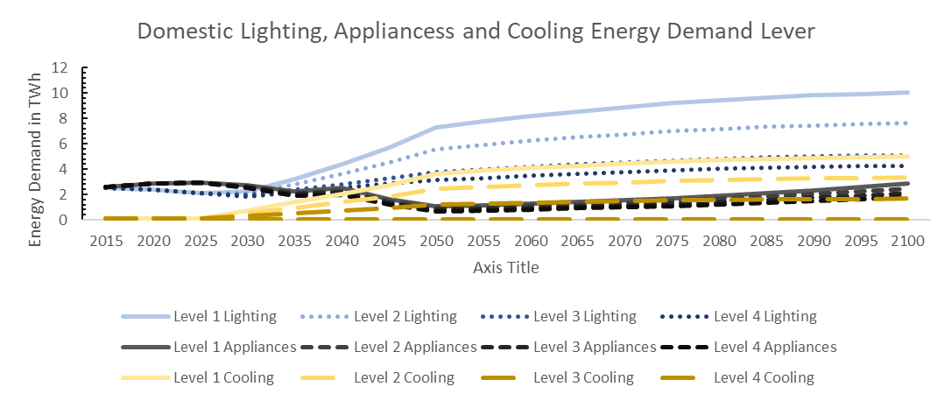

Figure Domestic lighting, appliances, and cooling energy demand to the year 2100

Non-domestic energy demand for lighting, appliances, and cooling are summarised in Figure 11. Non-domestic energy demand shows similar trends in demand where lighting has the highest energy demands. However, unlike domestic energy demand, where we anticipate change in behaviour to impact cooling needs, we do not expect non-domestic cooling energy demand to taper off to zero at level 4.

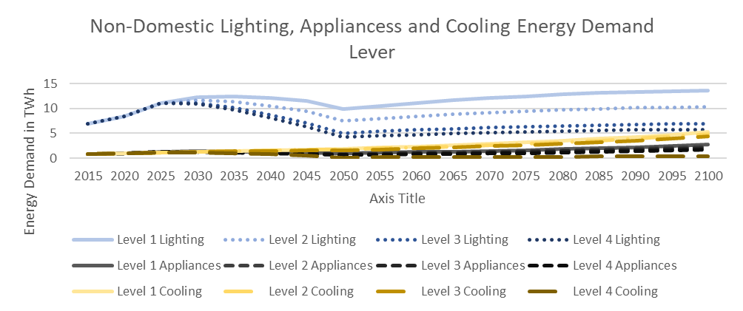

Figure non-domestic energy demand for lighting, appliances, and cooling

### Lighting, Appliances and Cooling Emissions

The energy supplied for lighting, appliances and cooling is calculated based on the energy service demand and energy intensity as follows:

Efficiency improvements are represented using an energy intensity index relative to the base year. This is instead of modelling individual technologies with different efficiency ratings, which was deemed too detailed for this model. Energy balance is calculated based on the energy supplied (activity) and efficiency:

Overall KCERT reports null greenhouse gas emission for lighting, appliances and cooling given the use of electricity, whose emissions are accounted for in the Electricity module. KCERT accounts of F gas emissions from non-domestic air conditioning. KCERT assumes constant AC demand per unit floor area and consistent floor area projections, so emissions are also multiplied by the index of AC demand per unit floor area to reflect changes in the level of cooling demand from the users’ choices.

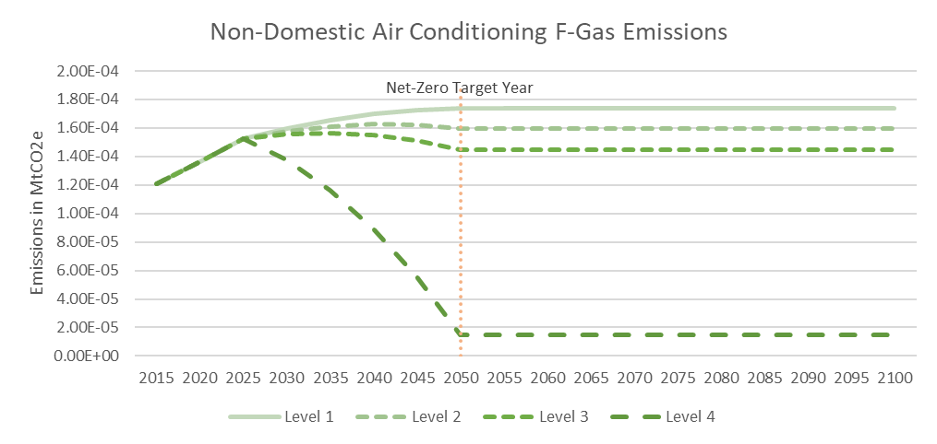

Figure non-domestic air conditioning F-Gas emissions by levers of ambition

## Industry

KCERT industry module calculates the energy balance, emissions and costs associated with different energy vectors, selected by the user as a share of the service demand, for four industrial sectors considered as biggest industrial energy users:

|  |  |  |
| --- | --- | --- |
| Retained KCERT | Added KCERT | Removed (Mackay) |
| Steel and Nonferrous metals  Cement | Tea  Sugar | Other Industry  Refineries  Chemicals |
|  |  |  |

### Key interactions

The industry module influences:

* Fuel demands for electricity, bioenergy, and fossil fuels. Decarbonisation strategies in the industry sector aim to use cleaner fuels for heat supply in industrial processes such as electrification, biomass and hydrogen while reducing the use of fossil fuels.
* Bioenergy and Waste Transformations since the supply of biomass for energy is considered as a decarbonisation strategy. However, bioenergy production is finite and therefore is controlled though the Land Use and Biofuels levers.
* Hydrogen Production. One of the decarbonisation strategies is the use of hydrogen gas for heating in industrial processes and therefore influences the hydrogen gas fuel demand.

The module is influenced by:

* Capture rates and efficiency penalties for Carbon Capture and Storage (CCS) processes in the GHG Gas Removal module

### Industrial Efficiency Lever

The industrial electrification lever allows the user to control the ambition levels sourced at the expert workshops for:

* Energy intensity index
* Process emissions intensity index.

**Energy Intensity Index**

In the Calculator, industrial energy intensity is the amount of energy consumed by an industrial sector to produce a unit of heat. It is a measure of the efficiency of industrial processes. Therefore, the energy intensity index represents a fraction of the base year energy required to supply each unit of demand and describes the level of ambition for energy efficiency improvements.

The energy intensity index for each industry sector is calculated from the baseline trajectory and the chosen ambition level. More specifically, the energy intensity index relative to the base year is calculated by multiplying the base year index by an adjustment factor to gradually transition between the base year profile and the target ambition level. This factor is defined by the following function:

1. If the current year is less than the start year apply one,
2. If the current year is greater or equal to the start year + time to deploy (target year) apply the target energy intensity divided by BAU energy intensity,
3. Else if the current year is equal to the start year apply a linear interpolation between one in the start year and the target year index in the target year.

The base year or business-as-usual energy intensity index is calculated as

**Process Emissions Intensity Index**

Process emissions intensity index captures the emissions per unit of production relative to the model base year. This lever allows the user to control the ambition levels for the process emissions intensity index relative to the base year. The emissions factor index for each industry sector is calculated by multiplying the baseline index, set to zero as the technology is yet to be deployed, by an adjustment factor to gradually transition between the baseline profile and the target ambition level. This factor is defined by the following function:

1. If the current year is less than the start year apply one,
2. If the current year is greater or equal to the start year + time to deploy (target year) apply the target emissions intensity divided by baseline emissions intensity,
3. Else if the current year is equal to the start year, then apply a linear interpolation between one in the start year and the target year index in the target year.

### Industry Carbon Capture and Storage (CCS) Lever

In KCERT industry CCS Lever consist of two sub-levers:

* Ambition for the share of heat processes with CCS – controlled by the Industry CCS lever, and
* Ambition for the emission capture rate of the heat process with ccs in each industry - controlled by the CCS capture rate lever in the CO2 Removal and Gases module

**Ambition for the share of heat processes with CCS**

This sub-lever allows the user to control the ambition levels for the share of heat process with CCS for each industry as a fraction of total number of factories in each industry. The user desired deployment curve of the share of heat process with CCS for each industry is calculated using if logic statement.

1. If current period is before the start year apply the baseline share. There is no record of CCS in Kenya as of 2015, the base year.
2. If the current period is after the chosen ambition level has been achieved (more than the speed of deployment since the start year) the user selected share is applied.
3. Else if the current period is between the start year and calculated completion year the share of industry heat process with ccs is linearly interpolated between baseline level (in start year) and the selected level (in completion year).

**Ambition for the emission capture rate of the heat process with ccs in each industry**

This sub-lever allows users to control the ambition levels for the capture rate of the heat processes with CCS. The user desired deployment curve for capture Rate for heat process with CCS.

1. If current period is before the start year apply the baseline capture rate.
2. If the current period is after the chosen ambition level has been achieved (more than the speed of deployment since the start year) the selected capture rate is applied.
3. Else if the current period is between the start year and calculated completion year the capture rate is linearly interpolated between baseline level (in start year) and the selected level (in completion year).

In Kenya carbon capture with CCS is a new concept but workable as the energy demand for the capture could be drawn from electricity which is 90% carbon free. Therefore, combining the grid electricity with CCS would lead to net negative emissions.

This sub-lever also controls the ambition levels for the efficiency index relative to the non-CCS equivalent process which corresponds to the capture rate ambition level. The efficiency index relative to the non-CCS equivalent process corresponding to the capture rate is calculated by linearly interpolating between the ambition levels above and below the actual capture rate applied in each year. It is assumed that the level 1 efficiency penalty is applied until level 1 ambition level has been exceeded.

### Industry Heat Process Shift Levers

These set of levers allows users to control the ambition levels for the share of heat supplied by:

|  |  |
| --- | --- |
| Retained KCERT | Changes to Kenyan Context |
| Electricity | No change: Electricity which is currently 90% renewable energy is an option for decarbonising the selected industries. |
| Bioenergy Solid | Shift to bioenergy solids is considered only in the cement, and steel and non-ferrous industries which currently rely on coal, heavy fuel oil and tyres. Tea and sugar industries already use biomass to generate thermal energy. |
| Gas Gaseous | Kenya does not foresee deployment of a gas grid, therefore KCERT assumes gas will be supplied through cylinders. The shift to gas for industrial heat processes considers hydrogen gas only and does not include biomethane. |
|  | |

Figure 13 displays the share of process heat supplied by the selected technologies. Electricity is the first in the priority order for supplying process heat to industry. The shift to biomass is second in the priority order increase in uptake targeting cement and metal production. Hydrogen gas is the third in priority order. High carbon fossil fuels (coal and oil) would meet shortfalls in demand.

Figure Share of process heat supplied by heating technology

KCERT assumes that the shares of heating demand by electricity, biomass, and hydrogen gradually transitions between the baseline profile and the user selected target ambition level. The baseline profile is that is the share of each technology at business-as-usual for each industry heat process is calculated as the base year share of energy demand met by the heat technology divided by the total demand in the industry type.

The base year share of energy demand by industry type is calculated by multiplying the efficiency of each heat process by industry type sourced from Kenya energy audit reports and previous literature by the energy balance, which is the final energy consumption by end use for all processes considered to be 'Heat Processes' including high temperature processes, low temperature processes, drying/separation, and others, sourced from national statistics.

The user selected deployment profile of share of industry heat processes is calculated by the following logical function:

1. If the current year is less than the start year apply the baseline profile,
2. If the current year is greater or equal to the start year + time to deploy (target year) apply the lever ambition level,
3. Else if the current year is equal to the start year apply a linear interpolation between zero in the start year and the ambition level minus the baseline level in the target year from the baseline profile.

Figure 14 summarises the aggregated industrial energy consumption in TWh per year by level of ambition. Decarbonisation strategies focus on phasing out dirty fuels such as coal and oil for low-carbon electricity, bioenergy, and hydrogen.

Figure Industrial energy consumption in TWh/yr. by ambition level

### Industry Energy Balance and Emissions

Energy demand in the base year for each fuel and Industry type is calculated from energy consumption and efficiencies in the base year. Energy Consumptions are calculated as:

* BAU Energy Balance Heat Processes: *Business as usual energy balance is given from secondary data as the final energy consumption by end-use for all processes considered to be 'Heat Processes'. This includes high-temperature processes, low-temperature processes, drying/separation, space heating and other*
* BAU Energy balance Electricity: *Business as usual energy balance for final energy consumption by end-use for all processes considered to be 'Electricity Processes'. This includes motors, compressed air, lighting, and refrigeration.*

The total base year energy demand for heat processes and electricity per industry is calculated by summing over all fuels for a given industry type to give the **total demand** of energy for each industry sector.

Heat share by input fuel is applied in hierarchical order: electricity first, then bioenergy, then gas and finally all the others. The actual share is calculated as the minimum between the ambition share and the residual share after we apply the shares for the fuels higher in the hierarchy. The residual share after electricity, bioenergy and gas is assigned to fossil fuel solid and fossil fuel liquid: it is split between them according to the respective proportion in the baseline shares.

For each fuel, the demand is also split into CHP (Combine Heat and Power) and non-CHP using the baseline CHP share per fuel (share of fuel which is used for heating in CHP plants). The electricity produced by CHP plants is calculated by taking the total CHP heat production and dividing it by the heat to power ratio. The net electricity consumed from the grid is the total electricity demand for electrical processes and heat processes minus the electricity produced by CHP plants.

The demand for heat processes and electricity is calculated by multiplying the demand in the base year and the expected sector growth. The sector growth is a fixed model input for all sectors. The demand for heat is then split into fuel demands according to the fuel shares giving activity that is the Heat supplied by fuel to each industry.

Industry sector emissions are treated as follows:

* Process Emissions

Process emissions are calculated by multiplying process emissions in the base year by the emissions intensity index (emissions factor index) and the sector growth (demand index). It is assumed that process emissions are captured by CCS at the same rate as combustion emissions.

* Emissions captured by CCS

Assumes that any carbon content removed in the process is released into the atmosphere and that the CCS process captures a fraction of this. Carbon content released is calculated as the fuel input (negative of the energy balance) multiplied by the emissions factor (emissions content factor for bioenergy). The emissions captured are calculated as the emissions released multiplied by the share of emissions that have CCS applied and the capture rate of the process.

* Greenhouse gas (GHG) emissions

For each GHG, emissions are calculated as the energy balance multiplied by the global GHG emissions factors for each fuel. For CO2 emissions captured in Carbon Capture and Storage (CCS) processes are subtracted. For the statements highlighted in red for industry specifically, they are going to be altered later especially with the removal of the gas grid from the system.

Figure 15 summarises the emissions over time from the four industries by level of ambition. In the absence of targeted interventions industry emissions can increase to 43.83MtCO2e in 2050. Metal production (ferrous and non-ferrous) is the leading emitter of greenhouse gases in the industrial sector. In total, targeted interventions at the highest level of ambition can lower greenhouse gas emissions from the industries to 1.79MtCO2e in 2050.

Figure Aggregate emissions in MtCO2e/yr. by industry

### Checksums

The industry module has two checksums:

1. A Checksum checking that all baseline shares add up to 100% in all years is added to the module for the BAU share of each fuel in the base year. It is calculated to be the share of energy demand met by the fuel divided by the total demand by the industry type. The checksum should equal to zero.
2. A checksum checking that the total activity of heat production across all fuels, both CHP and Non-CHP adds up to the total heat demand. Should show zero.

## Land Use and Biofuels

The land use and biofuel modules calculate how land in Kenya is used allowing users to control ambition levels for farming yield and emission intensity through better farming practices which reduce emissions, dedicating land to forests and/or growing bioenergy to reduce emissions through abatement, use of biofuels, and waste management.

### Key interactions

The Farming and forestry module influences the amount of raw domestic bioenergy resources available for processing into energy commodities and fuel demands for electricity, bioenergy, hydrogen, and fossil fuels. While the bioenergy module influences electricity supply from Energy from Waste (EfW) reduces demand for supply from other electricity generation technologies and is influenced by fuel demands for solid, gaseous, and liquid biogenic fuel, availability of domestic bioresources, share of biomass gasification, biofuel production and EfW plants with carbon capture and storage (CCS) and capture rates and efficiency penalties for CCS processes.

### Farming Yield and Efficiency Lever

This lever allows the user to control the ambition levels for:

* Livestock numbers and farming yield
* Agricultural Fuel Use - Bioenergy Liquid
* Emission Intensity Index for agricultural process emissions

**Livestock and Farming Yield Sub-Lever**

In terms of livestock numbers, the user controls the ambition levels for the number of livestock over time. Types of livestock considered and whether they produce greenhouse gas remains the same as in the Mackay Carbon calculator:

|  |  |  |
| --- | --- | --- |
| Category | Bioresource | Greenhouse Gas |
| Poultry | No | No |
| Cattle | Yes | Yes |
| Other | Yes | Yes |

The number of animals user selected deployment profile is calculated by multiplying the business-as-usual number by an adjustment factor to gradually transition between the business-as-usual profile and the target ambition level. This factor is defined by the function:

1. If the current year is less than the start year apply 1,
2. If the current year is greater or equal to the start year + time to deploy (target year) apply the target number divided by BAU number,
3. Else a linear interpolation is applied between 1 in the start year and the target year index in the target year.

Figure 16 summarises the user selected deployment profile of livestock capacity. The module assumes that reducing the number of livestock will reduce bioenergy availability as the amount of manure produced by Cattle and Other livestock will reduce and thus reduce GHG emissions through manure management and enteric fermentation.

Figure Livestock capacity ambition levels for number of poultry, cattle and other

In terms of land yield, the user controls the levels of ambition for how efficiently land is used approximated by increasing the yield of land compared to base year yield. User controls the ambition levels for yield index as a fraction of base year yield per unit area of bioenergy land bioresource per unit area, arable land for food, food produced per unit area and livestock grazing land per unit area. Figure 17 summarises the ambition levels set for the yield index lever. The model assumes that increasing the yield of land will increase the useful output from each unit of land meaning that the land area required to deliver a fixed output reduces, freeing up land for other uses.

Figure Ambition levels of the yield index as a fraction of base year yield per unit area.

The user selected deployment profile of yield index relative to the base year is calculated by multiplying the business-as-usual index by an adjustment factor to gradually transition between the business-as-usual profile and the target ambition level. This factor is defined by the function:

1. If the current year is less than the start year apply 1,
2. If the current year is greater or equal to the start year + time to deploy (target year) apply the target yield divided by BAU yield,
3. Else apply a linear interpolation between 1 in the start year and the target year index in the target year.

Consequently, the energy crop yield from land dedicated to bioenergy is calculated by multiplying the yield in the base year by the yield index. The user deployed yield index for arable land for food and livestock grazing land are used to calculate the land balance minimum for the respective land uses.

However, KCERT assumes the yields below are constant over time:

* Wood arising from baseline woodland - Bioresource per unit area
* Wood arising from additional woodland - Bioresource per unit area
* Straw arising from arable land for food - Bioresource per unit area

**Agricultural Fuel Use - Bioenergy Liquid Sub-Lever**

The agricultural fuel use-bioenergy liquid sub-lever allows the user to control the ambition levels for the share of all liquid fuels used in agricultural processes that are biofuels. The user-desired deployment curve of the proportion of biofuel replacing fossil fuel liquid used in agriculture is calculated using the following logic statement.

1. If the current period is before the start year KCERT applies the base year share/penetration.
2. If the current period is after the chosen ambition level has been achieved (more than the speed of deployment since the start year) the selected share/penetration is applied.
3. Else if the current period is between the start year and the calculated completion year the share/penetration is linearly interpolated between the base year level (in start year) and the selected level (in completion year).

This deployment curve is used to determine the share of fossil fuel liquid energy consumption in agriculture, which is calculated by multiplying the assumed energy demand for liquid fuel by one minus the share of liquid fuels substituted for biofuels

**Emission Factor Index for Agricultural Process Emissions Sub-Lever**

This sub-lever lets the user control the level of ambition for emissions intensity improvements for the following processes:

* Livestock Enteric Fermentation (emissions / animal)
* Livestock - Manure Management (emissions / animal)
* Arable Land for Food (emissions/unit area)
* Soil Management

The emission factor index measures the emissions intensity as a share of the base year emission factor value. The emissions intensity index relative to the base year is calculated by multiplying the base year index by an adjustment factor to gradually transition between the base year profile and the target ambition level. This factor is defined by the following function

1. If the current year is less than the start year apply one,
2. If the current year is greater or equal to the start year + time to deploy (target year) apply the target emissions intensity divided by BAU emissions intensity,
3. Else apply a linear interpolation between one in the start year and the target year index in the target year.

### Forestry Lever

The forestry lever allows the user to control the ambition levels for the amount of land dedicated to forests and bioenergy land. KCERT breaks down the forestry lever to include ambition levels for afforestation (planting new forests) and reafforestation (forest restoration).

KCERT divides the total land area into six land types:

* Forests - Land defined as forest.
* Bioenergy Land - Land for energy: Land that is used specifically for growing energy crops.
* Livestock Grazing Land - Grassland for livestock: Pasture and wild grasslands used for grazing animals
* Arable Land for Food - Land used for growing food crops.
* Settlement Land - All developed land including transport infrastructure and human settlements. Follows a fixed profile
* Other land use: land that cannot be described by any other land type and includes rock, bare soil, ice, any unmanaged land that does not, and cannot, fall in the other categories.

KCERT calculates how much land is available for each purpose and limits the land dedicated to these categories. These land uses will directly compete for available land. KCERT constraints the user-selected level of ambition on the amount of land dedicated to forests and bioenergy by requiring improved yield of land for livestock grazing/growing crops and/or reduced the number of livestock to achieve the most ambitious levels of deployment.

The land balance is calculated as:

* Define the baseline profile for how land is used. i.e., what happens with no user ambition.
* Calculate the minimum possible land required under each category.
* Calculate the maximum possible land-use change from the baseline profile for each land category.
* Calculate land-use change from baseline: Land dedicated to settlements and the minimum land required under the categories Arable Land for Food, Livestock Grazing and Other are protected and cannot be displaced by any user choices. Any remaining land is prioritised for forests up to the level selected by the user. The remaining land that can change category is utilised in the following order to accommodate this:
  + Other Land - Above minimum requirement
  + Livestock Grazing Land - Above minimum requirement
  + Arable Land for Food - Above minimum requirement
  + Bioenergy Land
* After this, any remaining land is prioritised for bioenergy up to the level selected by the user.
* Any land that there is no demand (from user deployment profiles) to recategorize will remain under its original classification.
* Calculate the applied land balance by adding the baseline profile and the land-use change from the baseline

The minimum land requirements for each land type are summarised as follows:

|  |  |
| --- | --- |
| Land Type | Minimum land requirements assumptions |
| Other Land | Fixed amount of land which is not suitable for any other purpose. |
| Livestock Grazing | The model is constrained to ensure enough land is dedicated to livestock grazing to support the livestock population. There are two options available to the user to reduce the amount of land required to support livestock.   * Population - reduce the livestock population (cattle and other livestock, excluding poultry) * Yield - increase the yield of the land so that each unit of land can support more animals |
| Arable Land for Food | The model is constrained to ensure enough land is dedicated to arable land for food so that a domestic food security constraint is met. This constraint is based on a minimum criterion for the share of food crops produced domestically.  Domestic food requirements will naturally increase over time as the population increases. It is assumed that the demand for food crops per capita remains constant. The user can reduce the amount of land required to supply the minimum demand for domestic food crops.   * Yield - increase the yield of the land so that each unit of land produces more food |
| Settlement Land | Assumed that the baseline profile for land used for settlements is fixed. |
| Bioenergy Land | Fixed amount of land which is not suitable for any other purpose (If any). |
|  |  |

### Land for Bioenergy Lever

This lever controls the sub-levers:

* The land area dedicated to bioenergy
* Share of agricultural waste converted to energy

The land area dedicated to the bioenergy lever is controlled by the forestry lever. The associated calculations are discussed in the previous section.

**Share of Agricultural Waste Converted to Energy Sub-Lever**

The share of agricultural waste converted to energy lever allows users to control the ambition levels for the share of the total amount of waste produced by agricultural processes that are diverted to energy purposes. KCERT considers the following agricultural waste sources:

* Wood arising from baseline woodland
* Wood arising from additional woodland
* Crop residue arising from arable land for food
* Manure from livestock

User Controls the share of the available resource collected for energy purposes for:

* Wood arising from baseline woodland
* Crop residue arising from arable land for food
* Manure (from livestock) deposited as slurry collected for energy

The share over time for these resources is calculated by multiplying the business-as-usual share by an adjustment factor to gradually transition between the business-as-usual profile and the target ambition level. This factor is defined by the function:

1. If the current year is less than the start year apply one,
2. If the current year is greater or equal to the start year + time to deploy (target year) apply the target yield divided by BAU share,
3. Else if the current year is equal to the start year apply a linear interpolation between one in the start year and the target year share in the target year.

The following shares are fixed:

* Wood arising from additional woodland (currently fixed to be the same as baseline woodland)
* Manure (from livestock) deposited as slurry. This is calculated as the slurry and total dry matter calculated for cattle, sheep and pigs weighted by population as of 2015.

The resource balance defines how the total resource is categorised including the fraction collected for energy purposes. The balance for each resource is calculated as the total resource multiplied by the share collected.

Implications of user choices include:

* Increasing the share of wood or straw arising collected only increases the supply of domestic bioenergy
* Increasing the share of manure (from livestock) deposited as slurry collected for energy increases the supply of domestic bioenergy and reduces emissions from manure management (see emissions)

Figure 18 summarises the land dedicated to forestry and bioenergy as per the forestry and land for bioenergy levers. Deforestation has historically been the main driver of emissions given the capacity of forest in carbon sequestration; therefore, priority is placed on land for afforestation and reafforestation at level 3 and 4. In 2015, less than 1% of land in Kenya was used for bioenergy crops. In Kenya, biomass resource could be produced/mobilised for the bioenergy sector through utilization of wastes and residues from ongoing Kenyan agricultural activity and through dedicating Kenyan lands to produce biomass and energy crops. Figure 18 shows the ambitions levels for the production of energy crops as bioenergy feedstock and transformation of agricultural waste into bioenergy.

Figure Land balance forestry and bioenergy

### Land Use Energy Balance and Emissions

The energy balances considered under land use are:

1. The energy content of the agricultural waste and solid bio for bioenergy land
2. Agricultural fuel use is assumed to follow a fixed profile for the following categories.
   1. Electricity
   2. Solid bioenergy
   3. Gas - this can be decarbonised using biomethane or hydrogen
   4. Liquid fuel - this can be decarbonised by increasing the share of liquid biofuel substitution controlled by the user.

The types of emissions considered are:

* Lifecycle emissions from collected bioenergy
* Land Use Emissions
* Agricultural process emissions
* Fuel use emissions which are assumed to have fixed emissions

The following energy commodities are assumed to have fixed lifecycle emissions factors (emissions per unit of energy commodity collected)

* Woodland business as usual dry waste
* Woodland difference dry waste
* Arable land for food dry waste
* Bioenergy land biomass (unprocessed)
* Manure management wet waste

The following land uses are assumed to have a fixed emissions factor (emissions per unit of land)

* Livestock grazing land
* Additional Woodland

The following land uses are assumed to have fixed emissions irrespective of the land balance for the category

* Settlement Land
* Other Land
* Baseline Woodland

|  |  |
| --- | --- |
| Forests | In the calculator, forests are assumed to sequester more carbon than they emit, resulting in a net removal of CO2 from the atmosphere.  Baseline forests emissions are assumed to follow a fixed profile based on historic planting and harvesting rates. Additional emissions are applied as an average emissions factor per unit of land. The emissions factor is based on the annual average emissions sequestered over the lifetime of the planted forest. (i.e., total emissions sequestered divided by lifetime.)  Logic: The carbon absorption potential of newly afforested areas follows an S-curve through the growth lifecycle before reaching maturity and carbon equilibrium.  With afforestation being distributed both geographically and in time, however, it would make sense for this calculator to model carbon absorption as an average absorption factor per unit of woodland. |
| Bioenergy Lifecycle Emissions | Under accounting rules, bioenergy has zero emissions at the point of combustion.  Lifecycle emissions attributed to domestically grown bioenergy should reflect the net change to the carbon stocks from growing, burning, harvesting and transportation. The net change in carbon stocks during growth (sequestration) and combustion (emission) will cancel out.  However, there may be a time lag between when the emissions are sequestered during growth and when the emissions from combustion (counted at the time of harvesting) would be accounted for. If we assume a short rotation period for land dedicated to bioenergy, then it seems suitable to assume that these both occur in the year of harvesting for simplicity |
| Livestock | ***Manure Management***  Emissions are calculated by multiplying the manure deposited as slurry not collected for energy by the emissions factor for manure management.  KCERT assumes that the manure collected for energy has no emissions (other than those applied under lifecycle emissions). KCERT also assumes manure not deposited as slurry has zero emissions. This will be reflected in the calibration of the emissions factor for manure deposited as slurry not collected for energy.  Thus, emissions reduction options include   1. Reducing the amount of manure deposited as slurry not collected for energy, reducing the amount of manure by reducing livestock numbers and increasing the share collected for energy purposes (User controlled: land use for bioenergy). 2. Reducing the emissions intensity of manure management by changing practices manure management emissions such as better storage and improved timing of application of manure to the land, among others. This is defined by a lever in the farming yield and efficiency lever, which defines an index for the emissions intensity change from the baseline.   ***Enteric Fermentation***  The overall contribution that enteric fermentation in livestock makes to GHG emissions depends on the number of livestock and the emissions per animal.  Emissions are calculated by multiplying the number of animals (Cattle and Other, excluding Poultry) by the emissions factor for enteric fermentation.  Emissions reduction options include:   * Reducing the number of animals (user-controlled: farm yield and efficiency). * Reduce the emissions intensity of enteric fermentation through diet, food additives, and selective breeding (user-controlled: farm yield and efficiency). |
| Soil Management | Soil management emissions are calculated by applying a user-defined energy intensity index to the emissions recorded in the base year. Emissions reduction options include reducing the emissions intensity of soil management which is user-controlled under the farming yield and efficiency lever. |
| Peatlands (covered in other land use) | Technically speaking, peatlands form because the land is too waterlogged to be conducive to the natural decomposition of plant material. The carbon matter trapped in the plants is therefore stored in peat bogs and would not be released unless the peat bog were to be drained. Following its draining, it was understood that re-wetting a peat bog would not necessarily return it to a carbon sink, but this technique could still be used to avoid further carbon losses to the atmosphere. |

### Waste Reduction Lever

The waste reduction lever contains three sub-levels that allow the user to control the following level of ambition:

1. Waste Reduction through recycling and diversion to energy processes
2. Landfill gas release
3. Total waste production

**Waste Reduction Through Recycling and Diversion to Energy Processes Sub-Lever**

This sub-lever allows the user to control the share of waste that is:

* Recycled (avoiding landfill emissions),
* Diverted to energy purposes
* Openly burnt (added to the model to consider Kenya’s local context, with ambitions aiming to reduce the amount of dry waste that is openly burnt)

KCERT represents the following types of waste and actions to manage it:

|  |  |  |
| --- | --- | --- |
| Waste Type | Definition | Action |
| Dry Waste | * Municipal solid waste* (MSW), * Construction and demolition (C&D) waste, * Commercial and industrial (C&I) waste.   \****Excludes food and garden waste*** | * Recycle, * Incinerate to generate electricity in an Energy from Waste (EfW) facility, * Open Burning (*added in KCERT to cater for the local context)* * Landfill |
| Wet Waste | * Food waste, * Garden waste, * Agricultural waste, * Slurry.   *\*The module excludes manure which is represented directly as a function of livestock numbers in the farming and forestry lever.* | * Recycle, * Composting (*added in KCERT to cater for the local context*) * Convert to biogenic gas energy resource in an anaerobic digestion facility * Landfill |
| Used Cooking Oil (UCO) | used cooking oil and tallow | * Recycle, * Convert to biogenic liquid energy resource, * Landfill |
| Domestic Wastewater | Includes waste coming from households through the sewers | * Recycle |

KCERT assumes that if the user selected shares for recycling and exceeds one then recycling is prioritised. This assumption prioritises recycling for all waste types as recycling is higher up in the waste hierarchy and usually has a more positive environmental impact. Therefore, the proportion of waste that is recycled is set to the proportion the user selected.

The priority for the remaining share of dry waste changes to the following to consider the Kenyan context:

* **Diversion to energy processes** calculated as the share of waste that is sent to energy from waste plant is calculated as the minimum of the user lever selection for the share diverted to energy and the remaining share after recycling has been considered.
* **Open burning** which is calculated as the minimum of the user lever selection for the share of dry waste that is burnt and the remaining share after recycling and energy production has been considered.

The priority for the remaining share of wet waste changes to the following to consider the Kenyan context:

* **Composting**, which unlike the Mackay carbon calculator, comes before diversion to energy processes and is calculated as the minimum of the user lever selection for the share composting and the remaining share after recycling
* **Diversion to energy processes** calculated as the share of waste that is sent to energy from waste plant is calculated as the minimum of the user lever selection for the share diverted to energy and the remaining share after recycling and composting has been considered.

The remaining share for all waste types is assumed to be sent to landfills.

**Landfill Gas Release Sub-Lever**

The landfill gas released sub-lever allows the user to control the ambition levers for the share of landfill gas emitted.

KCERT calculates the gas produced by waste deposited in landfills. Waste deposited in landfill sites before the model base year is represented with a fixed profile of landfill gas output. Landfill gas from the waste of each category deposited in landfills after the model base year is calculated by applying an assumed landfill gas yield profile to each period of deposit. Therefore, a unit of waste deposited in year X will continue to release landfill gas for years greater than X until the point of full decomposition.

Landfill gas can either be collected or released into the atmosphere

* ***Released into the atmosphere***: The user controls the share of total landfill gas produced that is released as fugitive emissions, incurring significant emissions due to the global warming potential of methane.
* ***Collection***: The remaining share of total landfill gas produced is collected for energy purposes.

Landfill gas collected is used primarily to meet biogenic gas demand with the remainder incinerated to produce electricity in Energy from Waste (EfW) facilities.

**Total Waste Production Sub Lever**

This sub-lever allows users to control the ambition levels for total waste production applied via a waste resource activity index controlling the amount of waste as a fraction of base year production, where greater ambition means lower waste production. Ambition levels are set for all the four waste types defined above. The total waste produced is calculated by multiplying the quantity of waste in the base year by the waste production activity index defined by the user; based on the selected ambition level.

### Waste Resource Balance and Emissions

To calculate emissions, the total demand for each state (solid, gaseous, liquid) bioenergy fuel resource is summed across the whole energy system. It is assumed that the available bioenergy resources from farming, forestry and waste are processed most appropriately to satisfy these demands. The priority order for satisfying demand assumed in the model is as follows:

* Solid Biomass
  + Domestic solid biomass feedstock
  + Imported solid biomass feedstock
* Biogenic gas
  + Landfill gas
  + Wet Waste - Anaerobic Digestion
  + Domestic solid biomass feedstock gasification
  + Imported solid biomass feedstock gasification
* Biogenic Liquid Fuel
  + Used Cooking Oil (UCO)
  + Wet Waste
  + Domestic solid biomass feedstock gasification
  + Imported biogenic liquid fuel
* All remaining feedstocks are either
  + Used to generate electricity in Energy from Waste (EfW) facilities
    - Dry Waste
    - Wet Waste
    - Used Cooking Oil (UCO)
    - Landfill gas
  + Exported
    - Domestic solid biomass feedstock

CCS: It is assumed that it’ possible to capture and store carbon emitted during the following processes by applying CCS

* Biomass gasification
* Biogenic liquid fuel production
* Energy from Waste

The share of the output fuel produced from CCS processes is controlled in the greenhouse gas removal (GGR) module. The efficiency of CCS processes is calculated by applying an efficiency penalty dependent on the process capture rate, to the efficiency of the equivalent process without CCS.

Auxiliary fuels for the conversion processes: It is assumed that auxiliary fuels required for bioenergy conversion processes are minimal and as such can be ignored for simplicity. Energy requirements for processes are assumed to be satisfied by the input/output fuel and included within the gate efficiencies of the plant.

KCERT assumes that each biogenic fuel has two emissions factors

1. Emissions Factor: the emissions associated with combusting bioenergy according to accounting rules
2. Emissions (Carbon) Content Factor: carbon stored within the resource
3. Biogenic resources Lifecycle Emissions Factor: any lifecycle emissions from the management or harvesting of the bioenergy feedstock

Under accounting rules, bioenergy emissions at the point of combustion are assumed to be zero.

**Emissions from Bioenergy Processing**

Emissions from conversion processes are calculated as the difference between the accounting combustion emissions of the input resources and output fuel (not the actual carbon content). This methodology is designed to ensure emissions balance across the model. Where CCS is applied the carbon captured and stored is subtracted from this calculated by multiplying the difference in carbon contained within the input resource and output fuel by the carbon capture rate of the process. Assumes that any carbon content removed in the process is released into the atmosphere and that the CCS process captures a fraction of this.

**Landfill Gas Emissions**

It is assumed that the landfill gas tracked is methane. Each unit mass of landfill gas released into the atmosphere has a CO2 equivalent to the mass of the resource released multiplied by the Global Warming Potential of Methane.

**Other Emissions**

KCERT also accounted for the Emissions fromcomposting**,** domesticwastewater, and open burning

## Electricity Generation

The electricity generation module calculates the total annual electricity production required after transmission, distribution, and seasonal storage losses. The module defines the technologies used to supply electricity demand, calculates the peak electric power demand and whether the user selected generation and demand shifting capacity are sufficient to meet it as well as calculates the associated energy requirements and emissions.

### Key Interactions

The module influences the fuel demands for bioenergy and fossil fuels and the total amount of CO2 captured using carbon capture and storage processes. The use of biomass for power generation impacts the demand for biomass produced from bioenergy and waste transformation, for which the ambition levels are controlled in the Land Use and Bioenergy module.

The electricity generation module is influenced by fuel demands for electricity from all other sectors.

### Seasonal Storage Lever

Seasonal storage of electricity allows an oversupply of electricity generated via renewable energy sources such as solar to be stored and used when demand is highest. Seasonal storage use is considered for shifting the electricity supply requirement and hence the required centralised generation capacity away from periods of peak demand. Unlike the Mackay carbon calculator, the model does not consider short term demand shifting from demand-side responses, vehicle to grid charging or dedicated batteries.

The seasonal storage lever allows the user to control the ambition levels for the maximum amount of electricity that can be stored for balancing at peak periods in seasonal electricity storage technologies. The maximum energy that can be stored between peak periods in seasonal electricity storage technologies is determined using the following logic:

1. If the current period is before the lever start year the baseline value is applied,
2. If the current period is after the lever end year the selected lever ambition level is applied,
3. If the current period falls between the lever start and end year a straight line between zero and the ambition level is applied where it is (constrained to be) greater than the baseline, greater than the lesser of the baseline in the start year and the ambition level and less than the greater of the baseline in the start year and the ambition level.

### Electricity Generation Capacity Levers

In KCERT, the electricity generation mix considers the following technologies:

|  |  |  |
| --- | --- | --- |
| RETAINED | ADDED | REMOVED (Mackay) |
| Nuclear | Power Inputs | Biomass CCS |
| Wind onshore | Geothermal | Wind Offshore |
| Hydro | Thermal (Kerosene and HFO) | Tidal stream, range |
| Biomass | Thermal (Kerosene and HFO) Mini Grid | Wave |
| Interconnectors |  | Gas CCS |
| Solar |  | Coal Unabated |
| Natural Gas |  |  |

The electricity generation capacity lever allows the user to control the levels of ambition for electricity generated through the identified technologies except for Thermal (Kerosene and HFO). Thermal (Kerosene and HFO) is modelled as a fixed capacity process, which will have no further deployment after the year 2030. Solar electricity generation includes both systems that feed electricity to the grid and mini-grid systems.

Electricity supply and capacity are calculated by combining the user selected and fixed capacity profiles. Electricity generation load factors are considered for hot and cold seasons. The maximum possible generation by each technology in each season calculated based on the user-selected ambition level, duration of the hot or cold season and the average load factor for the season.

In KCERT, the calculation for the annual capacity required to supply the electricity generated from each technology also assumes that the technology operates at the seasonal average load factor and that only the capacity required to supply the electricity generated in the season is required. If the maximum possible output is required to meet demand, then this will equal the user-specified capacity. Therefore, the capacity required is calculated by converting the electricity generated into a capacity (multiplying by the annual energy to power conversion factor and dividing by the fraction of the year in the season) and dividing by the load factor.

**Grid Capacity Requirement**

Grid capacity requirement measures the capacity in distribution and transmission networks for the maximum power. The capacity required distribution network is assumed to be equal to the level of the peak flow, which is calculated as the gross peak demand from the distribution network. The required capacity for the transmission network is assumed to be equal to the total capacity generation and storage technologies connected at the transmission network level.

New capacity for a given period is calculated as the maximum of:

1. Zero (capacity installations cannot be negative),
2. If scrappage is applied the capacity required difference from the previous year (if technology has been scrapped when not required, capacity = capacity required so the model must build at least the increase in capacity required as there will have been no spare capacity from the previous period).
3. The difference between the capacity of new stock required (capacity required minus base year stock) and the capacity of new stock built within the technology’s lifetime of the current period (capacity assumed to still be active).

Finally, the total capacity available for operation each year for each technology is calculated as the base year stock (capacity installed before the model base year) plus the new stock (capacity installed after the model base year) still available for operation in the given period.

**Peak Capacity Test**

The peak capacity test compares the peak electricity demand to the electricity generation and storage capacity assumed to be available at peak. In the calculator, each generation and storage technology have an associate peak contribution of capacity share or de-rating factor sourced from secondary data. The total capacity that can be relied upon to meet the peak power demand is calculated by multiplying the technology capacity installed by the de-rating factor for each technology. If this is less than the peak power demand, then seasonal storage meets the capacity shortfall.

Figure 19 shows the supply of electricity by the selected models to the year 2100 separated by the level of ambition. Geothermal is the leading source of electricity in Kenya providing about 40% of Kenya’s energy demand as of 2015. Geothermal development is projected to continue being the dominating power generation source and complemented by hydropower, wind, solar, nuclear and electricity imports from neighbouring countries. This trend is visible across the four ambition levels with differing supply scenarios.

Figure Electricity Supply by Source and Ambition Level

### Energy Balance and Emissions

**Electricity Demand**

Electricity demand is assumed to be constant throughout the year, therefore the calculator does not include the seasonal demand balancing module.

**Distribution**

Distribution losses are applied before electricity demand is passed to the electricity generation module. Therefore, energy balances for the distribution of electricity from electric service demands are pulled from all relevant modules, that is, buildings, transport, land use and industry.

**Transmission**

Similarly, transmission losses are applied before electricity demand is passed to the electricity generation module. The following technologies are assumed to be connected directly to the transmission network:

* Direct air capture
* Enhanced weathering
* Hydrogen produced through electrolysis

Total electricity supplied through the transmission network is calculated by summing the electricity input to the distribution network and the energy balance for all processes connected to the transmission network.

**Peak Demand**

Peak demand specifics the period where electricity demand is expected to be the highest as a ratio of the peak power input to the annual average power input for each process. The model assumes that the peak demand period of the year reflects the coldest day in the year, which is a peak period for heat supplied for hot water in domestic and non-domestic buildings. Peak reverse margins, which are equivalent to LOLE (Loss of Load Equivalent), is considered as the fraction of the total peak electric power demand required as reliable electricity supply capacity. The model assumes that the peak reserve margin will decrease as peak demand increases and is applied using linear interpolation between two fixed points for a high and low peak.

The energy balance for each technology is calculated based on the electricity generation and efficiency of conversion. Greenhouse gas (GHG) emissions are calculated by multiplying the fuel input (negative of the energy balance) by the emissions factor and subtracting the emissions content of the electricity output.

Figure 20 summarises the emissions from electricity supply generation in MtCO2e per year grouped by ambition level. The electricity mix in Kenya is predominantly green thus emissions are expected from four out of the eleven electricity supply sources. Kenya is considering importation of natural gas from Tanzania and or overseas as Liquefied Natural Gas (LNG) and also exploring sources of natural gas, introducing emissions from this electricity supply source. Higher levels of ambition show decarbonisation of the electricity sector by 2055.

Figure Electricity generation emissions in MtCO2e/yr. grouped by ambition level

## Transport

The transport module calculates the share of demand met by modes of transport, energy consumption, emissions, capacity and cost of all transport modes and road transport refuelling infrastructure. Decarbonisation pathways are achieved through the use of biofuels, hydrogen, electrification, and hybridisation, change of behaviour by reducing transport demand.

### Key Interactions

The transport module influences the fuel demands for electricity, bioenergy, hydrogen, and fossil fuels. Emissions reduction in the transport sector can be met through efficiency improvements, electrification, partial electrification/hybridisation, and biofuels.

### Data sources

For data sources various reports and databases were used. They include:

* Updated transport data report of 2018 by the GIZ.
* Kenya Civil Aviation Authority databases.
* Transport-Energy Database (Smart data kits)
* Economic survey 2016

For aviation variables such as aircraft efficiency, energy intensity, historical fuel consumption, domestic and international passenger distance travelled, and number of aircrafts were obtained from the Kenya Civil Aviation Authority databases. Historical fuel consumption, aircraft efficiency and energy intensity were obtained directly from this database. For domestic and international passenger distance travelled, were obtained by multiplying the aircraft distance covered either domestically or internationally by the total number of passengers who flew either domestically or internationally respectively.

For road transport variables such as total passenger distance covered by each mode, total distance covered by each vehicle / mode of transportation for both goods and people, number of vehicles for goods and human transport, their respective efficiencies, fuel consumption rates, total fuel used for the vehicles, and the current number of each vehicle type were obtained from both the Transport Energy Database and the Updated transport data report for 2018 and the economic survey for 2016.

Variables such as vehicle distance covered, their efficiencies and fuel consumption rates were directly obtained from the updated transport data report of 2018. For the total fuel consumed by all vehicles in Kenya, it was got directly from the economic survey of 2016. The number of vehicles with respect to their engine fuel type were obtained from the transport energy database.

Given the difference in data collection for the transport sector between UK and Kenya, majority of the required data inputs were calculated but were based on the three source documents mentioned.

### Transport Demand Lever

The transport demand lever contains three sub-levers that allows user control of ambition levels for the total demand for travel as total distance travelled per passenger and the proportion of the distance travelled by each model to explore how travel demand reduction, modal shifting for domestic passenger travel and increased occupancy rates of cars contribute to decarbonisation strategies.

1. **Domestic Passenger Travel Demand Sub Lever**

The domestic passenger transport demand per person across all transport modes is calculated two stages:

* Total average transport demand per person is set by the first sub lever which controls the ambition level for passenger travel demand per person. Just like the Mackay carbon calculator, the ambition levels for transport demand per person is multiplied by the population to give the total domestic transport demand.
* The share of total demand met by each domestic transport mode is set by the modal shift sub leavers which allow users to control the ambition levels for the proportion of total transport demand met by the domestic means of travel. Passenger distance travelled by each mode is calculated by multiplying the total domestic transport demand obtained in the first step by the share of total demand met by the mode.

1. **International Air Travel Demand Sub Lever**

The international aviation demand sub lever controls ambition levels for service demand for international air travel passenger distance travelled per person. Total international aviation demand is calculated by multiplying the passenger distance travelled per person by the population.

The number of international air travels is interpolated from actual figures for 2015-2020. The number of international air travels includes both Kenyan and non-Kenyan citizens since it was not feasible to determine the number of Kenyan international air travels from the data obtained from the Kenya Civil Aviation Authority.

Decarbonisation through modal shifting for international air travel is not feasible as international aviation is the only mode able to meet international travel demand.

1. **Vehicle Distance Travel Demand Sub Lever**

The vehicle distance travel demand sub lever allows for the control of ambition levels for occupancy rates for cars all types. The passenger distance travelled is converted to vehicle distance travelled by dividing by the occupancy rate (passengers/vehicle) for each mode.

KCERT assumed fixed occupancy rates for the following modes:

* Walking
* Cycling
* Bus
* Train
* Aviation

However, future iterations could consider including ambition levels for occupancy rates of other transport modes such as. bus, train to consider decarbonisation pathways on increasing occupancy of commuter transport through promoting larger buses or commuter trains rather than matatus.

The freight distance travelled is converted to vehicle distance travelled by dividing by the occupancy rate (mass/vehicle) of the mode. KCERT assumes that all freight modes have fixed occupancy rates.

Passenger and freight aviation demands are combined to give a single vehicle distance travelled for aviation. Total plane distance travelled calculated by adding the passenger distance travelled divided by the passenger occupancy rate and the freight distance travelled divided by the freight occupancy rate. The calculator assumes that the average occupancy of planes is constant and therefore there is a linear relationship between the passenger distance (service demand), vehicle distance (dictating emissions/fuel use) and the number of planes.

**Notes on Transport Demand Sub Levers**

The model only considers the energy saving of using alternative forms of transport and does not consider any of the addition benefits e.g., health benefits from walking or any of the potential costs. The problem with this is that care will need to be taken so that walking and cycling do not just always get recommended. An improvement to the model in the future would be the introduction of costs and benefits for each modal shift. However, it is unlikely find reasonable data for this.

KCERT like the Mackay carbon calculator treats the levers for domestic air travel and international air travel demand as independent because the fraction of domestic air travel linked to international air travel demand is low.

The following modes of demand have been specified for freight travel demand: LGV, HGV Rigid, HGV Articulated, shipping, aviation domestic and international. However, the level of demand from each freight mode is set to a fixed profile and there are no options for shifting demand between freight modes are represented in the model. It is assumed that there was little scope for modal shifts for freight. This is because freight often has definite timescales for delivery and changing the transport method would make it difficult to still meet that deadline. This model does not attempt to reflect the impact of the international trade in energy resources on international shipping demand.

The overall amount of freight demand could change dramatically if there is a structural break in the economy for consumer goods. E.g., a rapid expansion in 3D printing. This would be an interesting extension to the model but would be difficult to parameterise across the system.

### Light and Heavy Vehicle Type Distance Travelled Levers

The light and heavy vehicle type distance travel levers control the ambition levels for the share of light and heavy vehicles fuelled by electricity, hydrogen, hybrid-electric and biofuel. Light vehicles refer to cars, matatus (14 seaters), and light lorries (rigid HGVs), while heavy vehicles refer to HGV articulated, bus, passenger, and freight trains.

User specified shares are adjusted (if required) based on the following priority order

1. Electric vehicles are first in the priority order, so the user specified share profile is applied directly.
2. Hydrogen vehicles are second in the priority order. The share applied is the lesser of the user specified share and the share remaining after electric vehicles have been deployed. However, we note that hydrogen vehicles technologies are there but can be costly given that they are not mature yet. This is accounted by the ambition levels and action start year.
3. PHEVs (plug in hybrid electric vehicles) are third in the priority order. The share applied is the lesser of the user specified share and the share remaining after electric and hydrogen vehicles have been deployed.
4. Slack -ICEs (Internal Combustion Engines) are the slack technology that meet the remainder of demand after electric, hydrogen and PHEVs have been deployed.

This priority order will only influence the user selected share profiles where the total shares requested would otherwise exceed 100%. The priority order is designed so that PHEVs can function as a transitional technology. High PHEV share in early years can be displaced by high shares of zero emissions vehicles in later years.

Distance travelled by each vehicle type is calculated by multiplying the distance travelled for the mode by the share of the mode using the user-controlled share of engine type.

The use of biofuel liquid fuel is considered as a decarbonisation strategy for reducing greenhouse gas emissions produced from the combustion of fossil fuels in plug in hybrid electric vehicles and internal combustion engines. The share of biofuel liquid fuel consumed in each transport mode is calculated based on the user's lever selections. It is assumed that the share of biofuel will remain constant at the level in the base year until the lever start date. KCERT does not include vehicle costs incurred or efficiency changes resulting from biofuel substitution. The assumption is that vehicles could run on up to 100% biofuels if engines were designed to run at that level of biofuel usage. Given the time horizons under consideration it can be assumed that this would happen at no additional cost. In reality engines running on biofuels may have slightly lower efficiencies, but the difference is small enough to ignore.

### Aviation Efficiency Lever

The aviation efficiency lever controls the ambition levels for efficiency improvements measured using an energy intensity index which gives a measure of how efficient an aircraft is. Lower energy intensities mean greater efficiencies. In the calculator, the energy intensity lever defines an energy intensity index which represents the change in the amount of input fuel required to deliver each unit of vehicle distance travelled relative to the base year.

KCERT assumes the mitigation options for reducing the energy intensity of air travel are:

* Occupancy - Plane size and load factor captured in demand calculation and assumed to be fixed.
* Vehicle Properties - Engine efficiency, lightweight planes (retrofit seats), changes to the aerodynamic properties, retrofitting airframes to make planes more aerodynamic, R&D spend (resulting in improvements).
* Vehicle Operation - Efficiency of the routing between airports and air traffic control, which require no physical changes to the plane fleet.

The energy intensity lever should be assumed to control the actions on vehicle properties and operation.

### Aviation Biofuel Lever

The aviation biofuel lever controls the ambition levels for the share of biofuel used in aviation fuels. KCERT carries the assumption from the DfT analysis that biofuels can be used directly in normal aircraft engines.

It is assumed that the share of biofuel will remain constant at the level in the base year until the lever start date. The user desired deployment curve of the share of biofuels used in domestic and international aviation is calculated using if logic statement.

1. If current period is before the start year apply the base year share/penetration.
2. If the current period is after the chosen ambition level has been achieved (more than the speed of deployment since the start year) the selected share/penetration is applied.
3. Else if the current period is between the start year and calculated completion year the share/penetration is linearly interpolated between base year level (in start year) and the selected level (in completion year).

It is assumed that there are no vehicle costs incurred or efficiency changes resulting from biofuel substitution. The potential for using biofuels in aviation could be significant although there will be competition for resource with other sectors (captured within a whole model).

### Transport Energy Balance and Emissions

The energy intensity is specified in the base year for each input fuel for each vehicle type in the form energy per unit distance. Energy intensity profiles are calculated by multiplying the base year profile by the energy intensity index. Thus, higher ambition in the energy intensity lever results in lower energy intensities and therefore lower fuel demands. Energy consumption is calculated by multiplying the vehicle distance travelled by the energy intensity.

Energy balance calculated to define the fuel input requirements for each vehicle type. In the case of fossil fuel and biofuel use in ICE and hybrid vehicles, the user-controlled biofuel share for these modes are applied directly to specify the fraction of liquid fuel input to ICEs (Internal Combustion Engines) and PHEVs (plug in hybrid electric vehicles) that is biofuel. The fossil fuel (oil product) share is calculated as one minus the biofuel share.

Output from refuelling infrastructure from each variety of refuelling infrastructure is calculated by summing the energy balances of the appropriate fuels and modes. The net energy balance for each refuelling process is calculated as the fuel delivered to vehicles multiplied by energy consumption per unit of fuel delivered. H2 refuelling infrastructure also consumes electricity to compress and pump hydrogen into the vehicle. The amount of electricity consumed is expressed as a fraction of the hydrogen consumed.

The greenhouse gas emissions are calculated by summing fuel input multiplied by the emissions factor, for each fuel consumed.

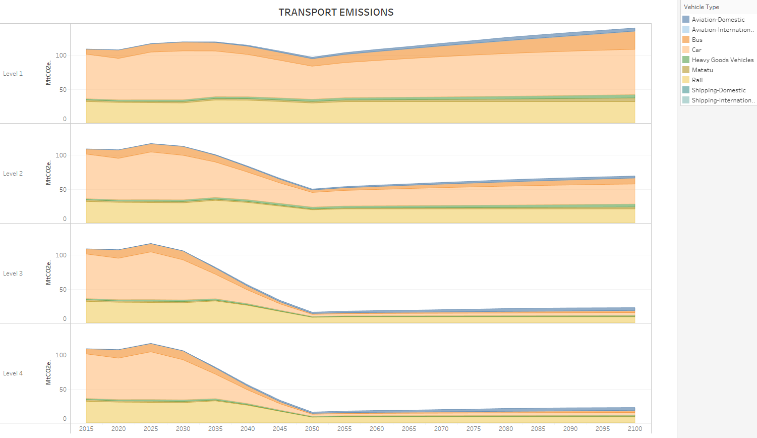

Figure : Transport Emissions with respect to each mode of transport

Figure 21 shows the drop in emissions in the transport sector with respect to each mode of transport. This is primarily due to the increase in efficiency in the domestic and international aviation sector. Increase in the adoption of hybrid, biofueled, hydrogen and electric vehicles, electrification of the Standard Gauge Railway (SGR) and adoption of public means of transport.

Figure : Energy consumption per type of fuel

Figure 22 summarizes the usage of the diverse types of fuel in the transport sector. The aim is to reduce the usage of fossil fuels in favour of biofuels, electricity, and hydrogen. At level one the transport sector is majorly powered by fossil fuel (oil) but at level 4 transport is powered by electricity and hydrogen mostly.

Figure : Passenger distance travelled per mode of transport

Figure 22 shows the distance covered by Kenyan passengers in a year. From level one to four the distance covered by Kenyans annually reduces. Also, the adoption of low emission modes of transport such as public transport (busses and matatus), cycling and walking increases from level one to four.

Figure :Transport energy consumption per engine type

Figure 24 shows the types of engines that power transport. From level one to four, the usage of Internal Combustion Engines (ICEs) reduces and at level four, the primary engine types in Kenya shift from ICEs to hydrogen and electricity powered engines.

## CO2 Removal and Gases Lever

The CO2 removal and gases lever contain sub-levers that control the ambition levels for the share of total "gas" supplied that is biogas and hydrogen, the ambition levels for the mix of technologies are used to supply the hydrogen demand, and the ambition levels for the share of dedicated Greenhouse Gas Removal technologies, the share of bioenergy conversion processes performed with Carbon Capture and Storage (CCS) and capture rates for all CCS processes across the system.

KCERT assumes a decentralised gas distribution system to reflect the local context where gas is primarily distributed in gas canisters for domestic and non-domestic use. From the sectoral stakeholder engagements, the establishment of a centralised gas grid for the distribution of gas is not feasible in the Kenyan context. KCERT gas source module is therefore an artefact of the model to allow for modelling the country's gas mix: LPG, Biogas and Hydrogen.

### Key Interactions

The lever is influenced by the fuel demands for gas, capture rates for all CCS processes and the share of bioenergy conversion processes performed with CCS and the share of biomass gasification, biofuel production and Energy from Waste (EfW) plants with CCS and is influenced by the amount of carbon captured in CCS processes across the system defines the requirement for offshore transportation and storage infrastructure.

### Hydrogen Production Lever

The hydrogen production lever allows users to control the share of hydrogen produced from various technologies listed below in order of priority:

* Biomass Gasification with CCS
* Zero Carbon Hydrogen Imports
* Steam Methane Reformation (SMR) with CCS

The three user levers directly control the amount of hydrogen produced by each method. The actual production from each technology is then determined by calling on the hydrogen production levers in the appropriate priority order until all demand is fulfilled. Any demand not satisfied by the three lever technologies is met by electrolysis. The technology options and priority order are designed so that deploying hydrogen across the model acts to decarbonise the energy system which we can assume is the user's intent.

**Note**: Electrolysis will only be zero/low carbon if the appropriate choices are made to decarbonise electricity generation. This is no different to the electrification of any other process.

Hydrogen production technologies not included

* Biomass gasification without CCS - This was omitted as a simplification as it does not offer a materially different decarbonisation solution. Biogas can be used in place of H2 in all areas other than transport, in which biofuel is a more likely use of bioenergy anyway.
* SMR without CCS - Not considered as this would offer no carbon savings over natural gas and would increase emissions due to efficiency losses in the conversion process.

### Greenhouse Gas Removal Lever

KCERT represents greenhouse gas removal in other modules as:

* Afforestation - Planting forests or enhancing management of existing forests, with growing trees taking up additional CO2
* Bioenergy carbon capture and storage (BECCS) - Combusting biomass to provide energy, with the CO2 released from the organic matter captured and then stored; or capturing and storing the CO2 released by organic matter during the process of converting biomass into other forms of biofuel.
* Covered by various BECCS processes across electricity generation, hydrogen production, bioenergy and waste conversions and industry

The greenhouse gas removal lever specifically controls options for the levels of ambition for the following greenhouse gas removal (GGR) processes:

* Direct Air Capture - Branched frames supporting amines ("artificial trees") capturing CO2 from the air which is recovered by washing in a vacuum and then stored. Note that this solution would be two times to four times more energy-intensive than the solutions above or capture CO2 at the source following combustion.
* Enhanced weathering - Adding crushed silicate rocks to soils, enhancing the natural process of CO2 capture by these rocks, with potential co-benefits in soil nutrients. This process would require substantial amounts of pulverised rocks

Under direct air capture user directly controls the amount of CO2 captured and stored each year. CCS offshore transportation and storage infrastructure is required to permanently store any carbon captured. While enhanced weathering sub-lever the user controls the amount of CO2 sequestered/absorbed each year.

### Bioconversion with CCS

The conversion of biogenic resources into different fuels requires energy and so results in CO2 emissions; by applying carbon capture and storage (CCS) to biotransformation, there is the potential to remove CO2 from the atmosphere resulting in negative emissions. This lever allows users to control the ambition levels for the share of the following bioenergy (and waste) conversion processes with CCS applied:

* Biomass gasification
* Biogenic liquid fuel production
* Energy from Waste

### CCS Capture Rates Lever

The capture rate of a CCS process determines what proportion of the total CO2 emissions can be captured. The CCS Capture rate lever allows the user selection for the capture rate of each CCS process in the model. KCERT assumes that the capture rate selected by the user is the average capture rate applied across all installations, implying that all installations are modified to achieve the selected capture rate. This neglects the fact that plants designed for a certain capture rate may find it difficult to increase their capture rate later. The efficiency of CCS processes is calculated by applying an efficiency penalty dependent on the process capture rate, to the efficiency of the equivalent process without CCS.